Courses Available Via Zoom for Winter 2021 Through Spring 2022

These courses are available to your agency or organization at no cost. A FEMA Student ID is needed for registration. Find your FEMA SID here.

MGT-323: Instructor Development Workshop (20 hours*)
This course primarily serves to give insight into adult education and enhance the instructional skills and styles of experienced instructors. The course focuses on best teaching and training practices, and it enhances understanding of instructor competencies set by the International Board for Standards
for Training, Performance, and Instruction. It incorporates effective problem-based instruction in addition to the traditional lecture format. More information on this course can be foundhere.

*Note: This course is an 20 hour-long course delivery over five consecutive days. Each day is four hours long.

Date: Monday, Jan. 24 - Friday, Jan. 28 Time: 10:00 AM - 2:00 PM CST (all days) Course ID: 28671

Access Code: NCBRT323

Date: Monday, Feb. 14 - Friday, Feb. 18 Time: 10:00 AM - 2:00 PM CST (all days) Course ID: 28672
REGISTER

Access Code: NCBRT323

Date: Monday, Mar. 14 - Friday, Mar. 18 Time: 10:00 AM - 2:00 PM CST (all days) Course ID: 28673
REGISTER

Access Code: NCBRT323

Date: Monday, Mar. 28 - Friday, April 1 Time: 10:00 AM - 2:00 PM CST (all days) Course ID: 28674
REGISTER
REGISTER

Access Code: NCBRT323

Date: Monday, April 4 - Friday, April 8 Time: 10:00 AM - 2:00 PM CST (all days) Course ID: 28675
REGISTER

Access Code: NCBRT323

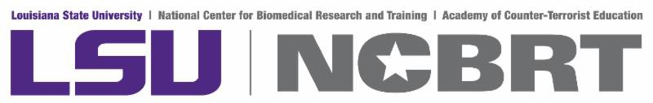Questions about our national open enrollment courses?

Contact Our National Open Enrollment Coordinators

