AWR-343
HURRICANE AWARENESS

Join us for our Hurricane Awareness course and increase your understanding of the latest knowledge in hurricane science, forecasting, warning, and preparedness. Enhances your ability to identify and describe the hazards associated with hurricanes and to better prepare for and mitigate the impacts of high winds, heavy rain, and storm surge.

DATE: TIME:

October 19th, 2021 12:30pm - 4:30pm ET

HOSTING AGENCY:
Florida Healthcare Coalitions

REGISTRATION POC:
WHO SHOULD TAKE THIS COURSE
- Citizen/Community Volunteer ✓ Law Enforcement
- Education ✓ Health Care
- Emergency Management ✓ Public Health
- Emergency Medical Services ✓ Public Safety Communications
- Fire Service ✓ Public Works

MODULES
- Hurricane Structure and Hazards
- Hurricane Forecasting and Warning
- Hurricane Advisory Products
Stephen Hughes
269-466-6431 | sthughes@hawaii.edu

REGISTRATION LINK/ INFORMATION:
https://ndptc.hawaii.edu/training/delivery/2970/ Camera and microphone are highly recommended

ELIGIBLE CONTINUING EDUCATION:
Registration Code: 86321

APA, AICP Member | CM | 3.5 | ASFPM, CFM | 3.5 CEC
IAEM, CEM/AEM |  |  | 4 E/G
IACET |  |  | 0.3 CEU

NATIONAL DISASTER PREPAREDNESS TRAINING CENTER
NOAA Inouye Regional Center
1845 Wasp Blvd Building 176, Honolulu, HI 96818 PHONE: 808.725.5220 • FAX: 808.725.5230

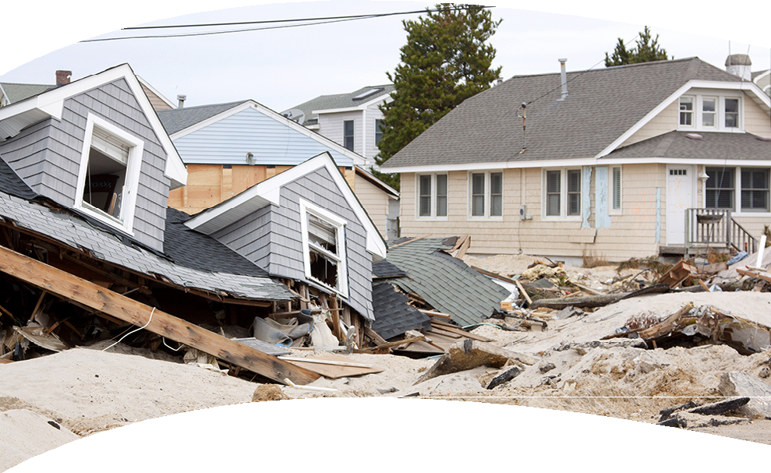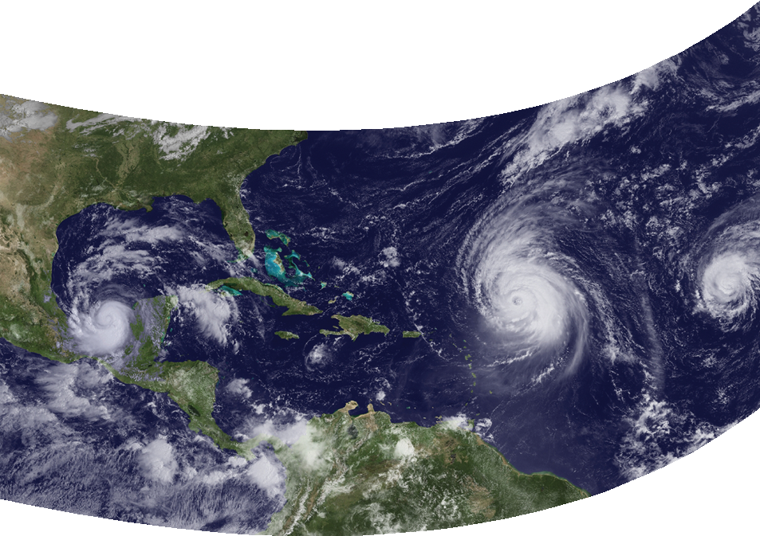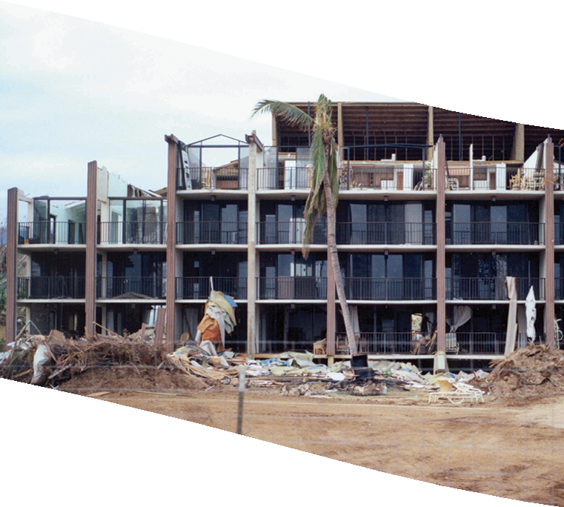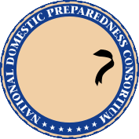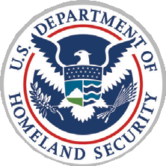

As a member of the National Domestic Preparedness Consortium, the NDPTC is a DHS/ FEMA training partner dedicated to providing critical all-hazards training throughout
the United States and its territories with an emphasis on natural hazards and island and coastal communities

