AWR-308

Natural Disaster awareNess
for Caregivers

Join us for our Natural Disaster Awareness for Caregivers course and gain a greater understanding about natural hazards, risk, vulnerability, and disaster preparedness to build better resilience for at risk individuals receiving care functions for medical, functional, or access needs. Learn how to prepare for the impacts of local natural hazards, identify methods for assisting care receivers to prepare for natural disasters and identify appropriate preparedness actions to take during a disaster.

DATE: TIME:

October 14th, 2021 12:30pm - 4:30pm ET

HOSTING AGENCy:
Florida Healthcare Coalitions
WHO SHOULD TAKE THIS COURSE
- Citizen/Community Volunteer ✓ Law Enforcement
- Emergency Management ✓ Public Health
- Emergency Medical Services ✓ Private Sector/ Corporate Security
- Fire Service ✓ Safety Professionals
- Governmental Administrative ✓ Public Works
- Healthcare ✓ Other
MODULES
- Caregiver Preparedness
- Care Receiver Preparedness
- Comprehensive Activity

REGISTRATION POC:
Stephen Hughes
269-466-6431 | sthughes@hawaii.edu

REGISTRATION LINK/ INFORMATION:
https://ndptc.hawaii.edu/training/delivery/2969/

ELIGIBLE CONTINUING EDUCATION:
Camera and microphone are highly recommended

Registration Code: 23081

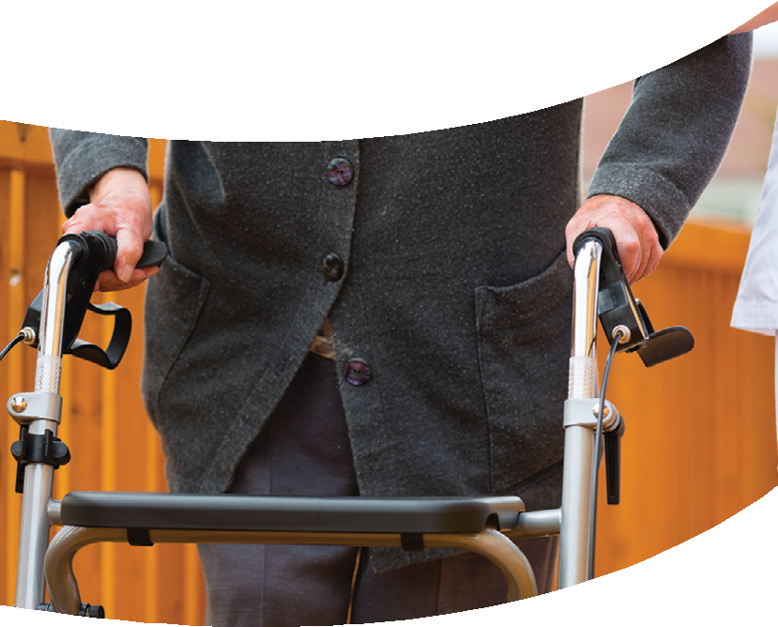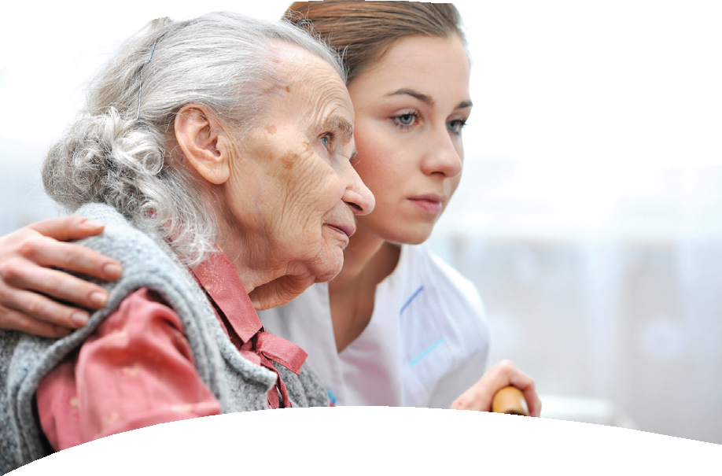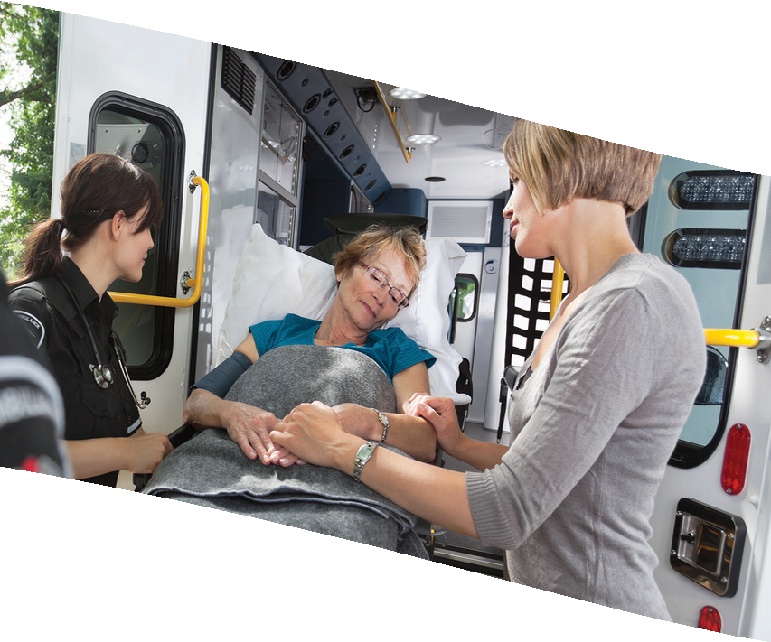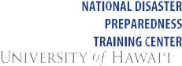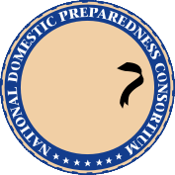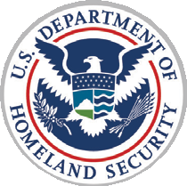

As a member of the National Domestic Preparedness Consortium, the NDPTC is a DHS/ FEMA training partner dedicated to providing critical all-hazards training throughout
the United States and its territories with an emphasis on natural hazards and island and coastal communities
Association of State Floodplain Managers (ASFPM), CFM 3.5 CEC International Association of Emergency Managers (IAEM), CEM/AEM 3.5 E International Association for Continuing Education & Training (IACET) 0.3 CEU

NOAA Inouye Regional Center
1845 Wasp Blvd Building 176, Honolulu, HI 96818 PHONE: 808.725.5220 • FAX: 808.725.5230

