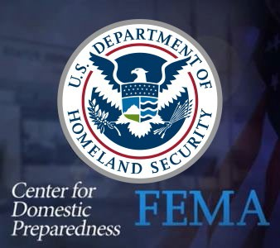Federal, State, & Local Roles in Medical Emergency Response

Course Description:
This is a virtual course offered in coordination with the Center for Domestic Preparedness (CDP).
Explores the roles of local, state, and federal governments and entities in supporting and enabling effective community-based response and recovery to a health or medical emergency. Emphasizes the critical importance of multi-level coordination to optimize community health system response and recovery.
1.25-hour Awareness Course

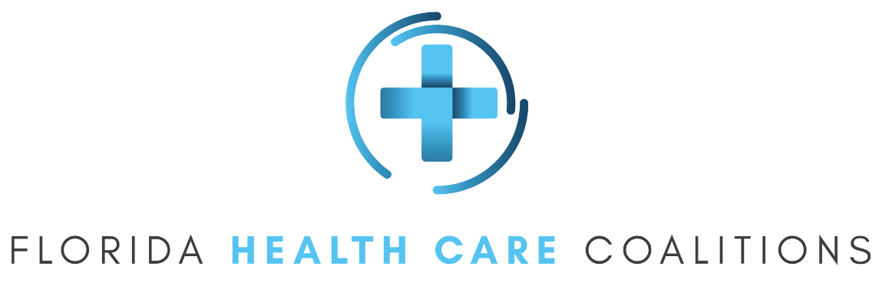

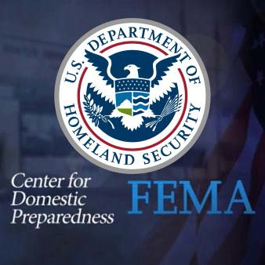Federal, State, & Local Roles
in Medical Emergency Response

To apply for this class, follow the instructions below: October 12, 2021 from 10am to 11:15am (EST)

- Have your FEMA SID number and password. You must have a FEMA SID number before you can apply for the class.
  - If you need a FEMA SID number, go to: https://cdp.dhs.gov/FEMASID and click “Register for FEMA SID” or click “Forgot FEMA SID?” if you have forgotten your FEMA SID.
  - Registering for a FEMA SID number does not register you for this class. You must apply for the class separately.

- Click this link to apply for the class: Click Here to Apply.
  - Enter your FEMA SID and password.
  - A CDP Training Registration System (TRS) application for 22NV-0187 HCV5 will open.
  - Complete the required fields.
  - Click the "Review and Submit Application Now" button.
Complete the application process by clicking the affirmation checkbox and providing your digital signature by entering your name and FEMA SID password.
(If you have trouble with the link, go to https://cdp.dhs.gov/students and enter 22NV-0187 HCV5 in the "Have a Promo Code?" box. You must enter the promo code exactly as it appears here to successfully apply).

Note: For Private Sector participants, when completing the application, please select Local Government for the jurisdiction.

- If you encounter any errors, please do not attempt to bypass or skip through them. Please document the error with as many details as possible and/or screen shots (print screen) and submit to FEMASIDHELP@cdpemail.dhs.gov so the error can be documented and addressed by the development team. Once the error has been reported, then proceed.

