RESPIRATORY PROTECTION PROGRAM MANAGEMENT TRAINING

Wednesday, July 21st from 8am - 5pm
Children's Board of Hillsborough County

1102 East Palm Avenue Tampa, FL 33605

This course will review the OSHA standards & requirements for a respiratory protection program and will include information on respirator types, protection factors, medical clearance, fit testing, and writing your respiratory protection plan!
The target audience is whomever manages your organization's OSHA/Safety/Respiratory Protection Compliance.

Register here.

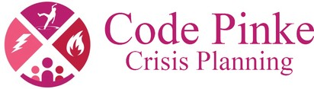

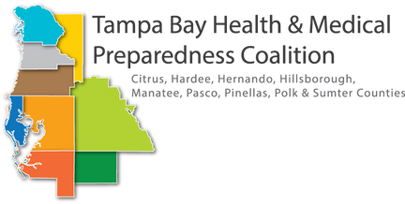Questions? Contact Hunter Zager
at Hunter.Zager@TampaBayHMPC.org or (727) 580-2431.

