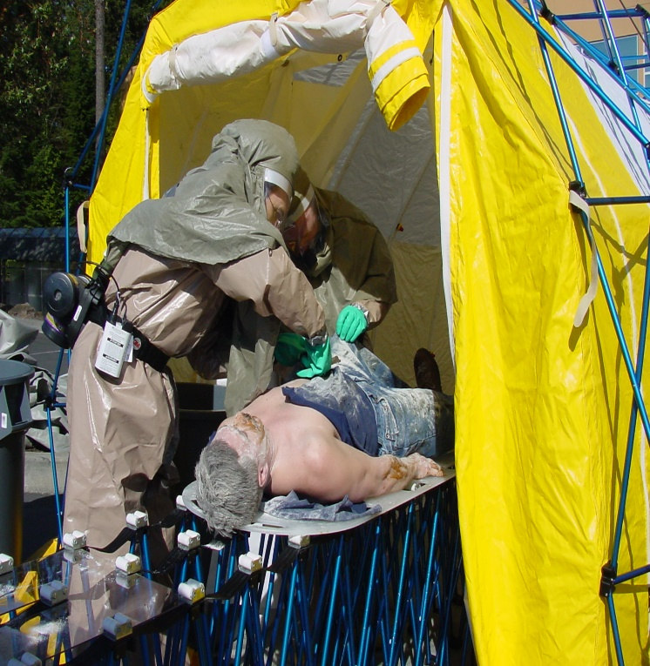  HOSPITAL EMERGENCY RESPONSE TRAINING FOR MASS CASUALTY INCIDENTS (HERT)  Thursday, October 15, 2020  The Hospital Emergency Response Training for Mass Casualty Incidents (HERT) course addresses healthcare response at the operations level for the facility and its personnel.  This is 8-hour course is intended for healthcare responders such as physicians, nurses, administrators, security personnel, environmental staff, and other hospital staff.  This course is offered thru FEMA Center for Domestic Preparedness  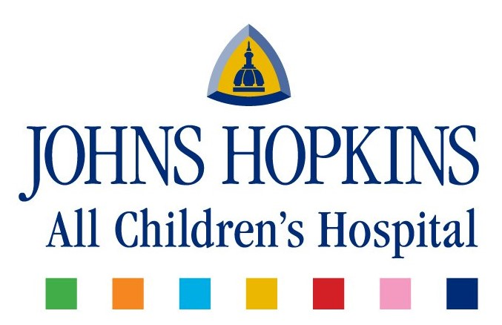  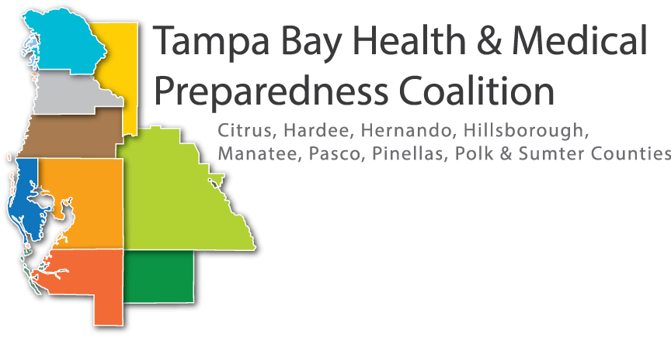  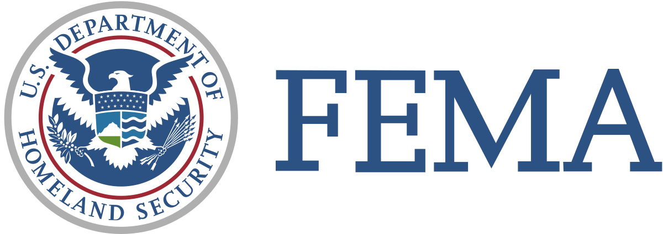 | VIRTUAL LEARNING OPPURTUNITIES  Perform simple triage and rapid treatment© (start) and jumpstart procedures within the emergency treatment area (ETA) during a hospital response to a mass casualty incident involving contamination.  Conduct operations in an eta while wearing appropriate personal protective equipment in response to a mass casualty incident involving contamination.  Understand Hospital Incident Command System  Chemical, Biological, Radiological, Nuclear, and Explosive Modalities  Please contact Scott Seibert  sseiber1@jhmi.edu  for  Registration link and details.  Registration due by October 8, 2020

